Preparation of the engine before increasing the fueling.
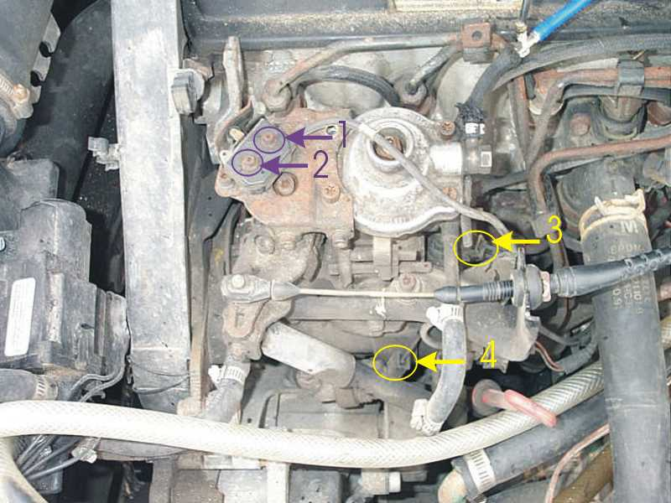
1. It is necessary to unscrew the screws #1 and #2 and to withdraw the limit-switch. (you probably have a cover over), You can use tie-rap and fix the switch elsewhere (but it must remain open)
This modification makes it possible turbo to function full-time instead of compressing only when you ask for all the power.
2. Now, to disconnect the connector #4 and to find a means of connecting the selenoid which is below of this connector #4 on the same wire as the connector #3 (fuel cut-off selenoid). You can let the connector #4 hang, it is now useless.
This modification prevents the pump from "delaying" the timing to reduce the Nox (polution) It is necessary that this selenoid(#4) is activated (12v) with each time the engine is ignited to keep the advanced timing even with low RPM.
These 2 modifications will help the softer, more powerful engine to be (a little) and especially more economic.
ATTENTION I AM NOT RESPONSIBLE IF YOU BREAK YOUR PUMP Because OF BAD HANDLING. with your risk and dangers...
ADJUSTMENT OF THE FUELING
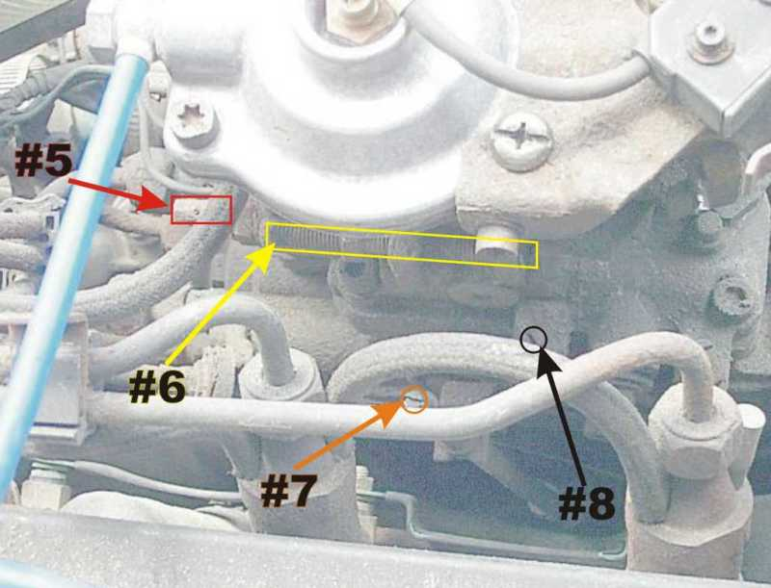
1. Take in note the rpm in Idle of your car when the engine is hot.
2. It is necessary to withdraw (tear off) the plastic cap which surrounds the screw #5 (max fueling adjuster). Under this plastic cap a 2e protection is; a metal ring... You can use a flat screwdriver to break this ring (a dremel can also do the work). (it is the only screw of the pump which has these protections)
3. Using a key 13mm, give off the lock-nut of the screw #5 and turn the screw #5 until the rpm is of 300rpm moreover than your regular Idle. Tighten the lock-nut.
4. Readjust your Idle with its value of origin with the screw #7 (service idle adjuster) for those which do not have the conditioned air and the #8 (idle adjuster) for the lucky ones which have it.
IF Idle do not want to go down again or that when you release the pedal on the motorway and that the car does not seem "to compress" correctly, it is possible that you have to unscrew the screw #6 a little (residual fuel quantity adjuster).
If it is not fast yet enough for you, begin again at stage 3 while turning the screw #5 (max fueling adjuster) of a half turn at the same time.
Note that too much smoke = too much fuel = too high temperatures of combustion = not good...
If all were carried out correctly, your vehicle should be very close to 90hp and 140lbs of torque. (as fast as the TDI)
Next article: Let us add PSI...
INCREASE IN THE PRESSURE OF TURBO BY A READJUSTMENT OF THE WASTEGATE.
1. Initially and above all, you find turbo-gauge or a gauge industrial 0-30PSI (low-cost: gauge for the swimming pool filters: 5$)
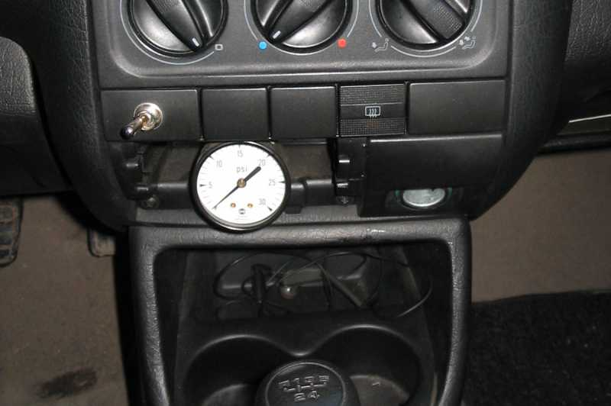
2. Install it with "T" on the tube which will connect on the lid of your pump (see the blue tube close of the #5 on the photo preceding one). For the remainder, follow the instructions of the manufacturer of your turbo-gauge.
3. It is necessary to preserve in note the maximum pressure that the turbo product before the readjustments. Coming from the factory, the 1.9td give between 8 and 12 PSI; more often, VW adjusted with 8PSI but specifies that between 8 and 12 it is OK.
4. Locate the lever of the wastegate (see photo) IF your turbo is not equipped with this type of wastegate with external adjustment, you will have to readjust it in another way who is called "Boost Bleed".
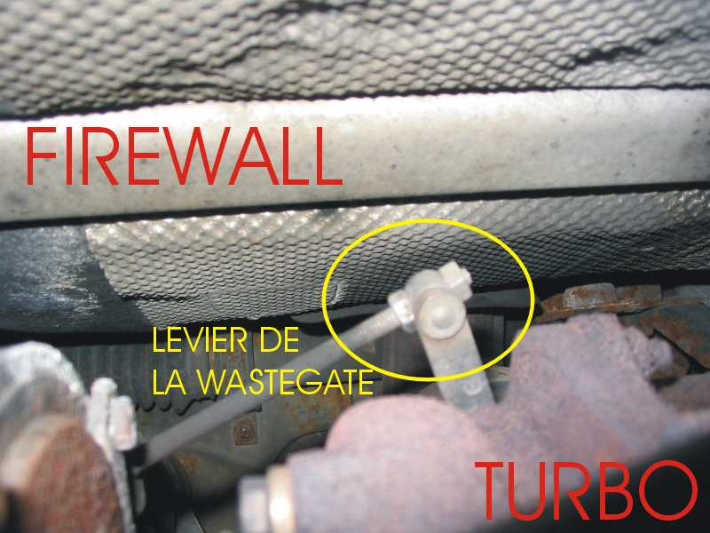
5. For those which have the wastegate with external adjustment, firstly it is necessary to withdraw the clip of protection which covers the 2 locknuts, then you must unscrew a little the locknut which is on the end of the stem to release the lever of the wastegate. Now, the readjustment is done as follows: the more the lever is towards the end of the threaded rod, the more the PSI will increase. I recommend to you to increase by small stages and to make test-drive. Be certain to tighten the 2 well locknuts before starting the car if not, bye bye gasket of head because the wastegate will not open and the turbo one can give 25psi easily.
ATTENTION, in top of 15 psi, the wastegate has more misery to do its work and can let assemble the boost a little higher than than you want, when you request more 14psi from turbo, keep an eye on the gauge and attention not not to exceed 15psi too much. (mine sees 20psi regularly and I did not break yet my gasket of head (230000km))
Then I wish you Good tuning!
(next stage, hybrid pump 1.9td/1.6td)
WITH ALL THOSE WHICH REQUIRED OF ME HOW THE CONSUMPTION OF THE AFFECTED CAR EAST: 1002.5km with 53.95L (5.4L/100km) mixed way motorway (110km/h) and city (15% city)
I ever made a success of that before when the car was stock.
OPTIMIZATION OF THE PUMP FOR A CURVE OF FUELING PROPORTIONAL TO THE PRESSURE OF TURBO
1. Find an old pump of 1.6 TURBO-DIESEL (Jetta/passat 1983-1992)
2. Locate the lid of the injection pump of 1.6td. (close to the #1 and #2 of the first photograph of this C-it-yourself). ( the 1.6 have a large screw in the center whereas the 1.9 does not have any)
3. Maintanant, to unscrew 4 screws TORX which retains this lid.
4. Under this lid, you will find a rubber membrane with a stem of fixed above as well as a spring. KEEP the stem and the diafragme and close again the remainder of the pump of 1.6td.
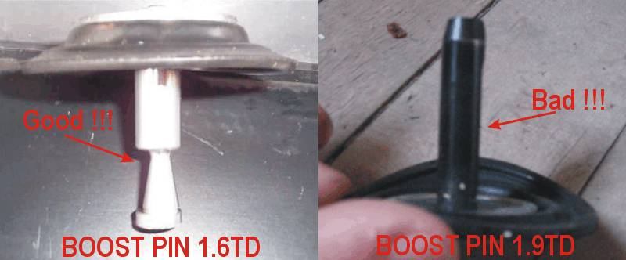
5. Observe the stem of the 1.6td, the end of the stem is in the shape of reversed cone which was engraved eccentric compared to the center of the stem. The reversed cone makes it possible the pump to react to the boost and decentring enables YOU to adjust the curve of fueling (the adjustment is done while turning of a few degrees the assembly membrane and stem towards the left or the right-hand side compared to the pump)
6. Locate the lid of the injection pump of your 1.9td. (close to the #1 and #2 of the first photograph of this C-it-yourself).
7. It is necessary to unscrew 4 screws TORX which retains this lid.
8. Under this lid, you will find a rubber membrane with a stem of fixed above as well as a spring. REPLACE the stem and the diafragme of your 1.9td by those of the 1.6td. I advise you to place the stem of 1.6td with the cone decentred towards the momentary side of your car; in this way, you will begin your adjustments with the least aggressive profile (and less soot)
9. Close again your pump of 1.9td.
NOTE that it is possible that you must readjust the screw #5 (max fueling screw, second image of the DIY) to hold the soot on the reasonable side.
The adjustment is done while turning the assembly diafragme and stem and while testing on the road. The ideal it is not to have of smoke with bottom rpm and to have passed the 3/4 of the pedal of them. In normal control, I use only the 3/4 of the travel of the pedal (I swear you that it is VERY sufficient); the last quarter (and bottom) are not useful only when I require really for a surplus of power and that I do not worry any more to increase the layer of SMOG to the top of Montreal....
Please, NOT TO ADD COMMENTS At EC THREAD.
If you have questions, additions or precise details, forwarded me them by e-mail, if it is relevant, I will add it to this DIY.
Next stage: INTERCOOLER (for small a 1000km by fuel 50L in normal control (850km in aggressive control)
This part will not be really C-it-yourself but rather a photograph of my tubing of intercooler to guide you in your projects.
The tubes are actually pipes of radiator which I bought at Canadian-Tire, 3 tubes in "L" of the diamêtre of my entries of intercooler and a pipe which is diameter of the exit of turbo. Some supports of stainless later and here is work.
Note that I have to move back the radiator of 2 inches to make place with the intercooler of Mazda 626.
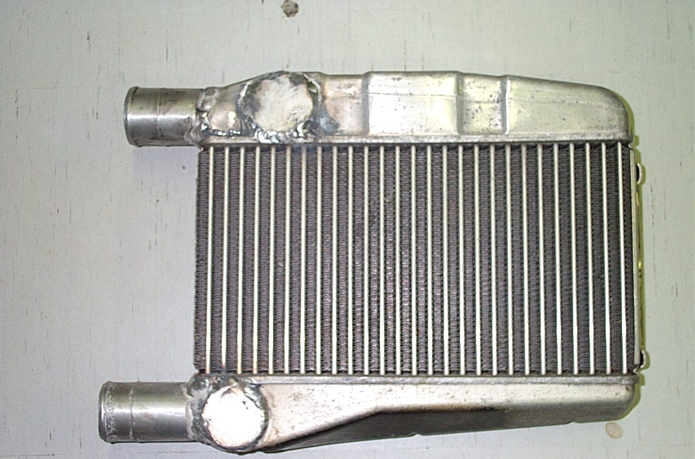
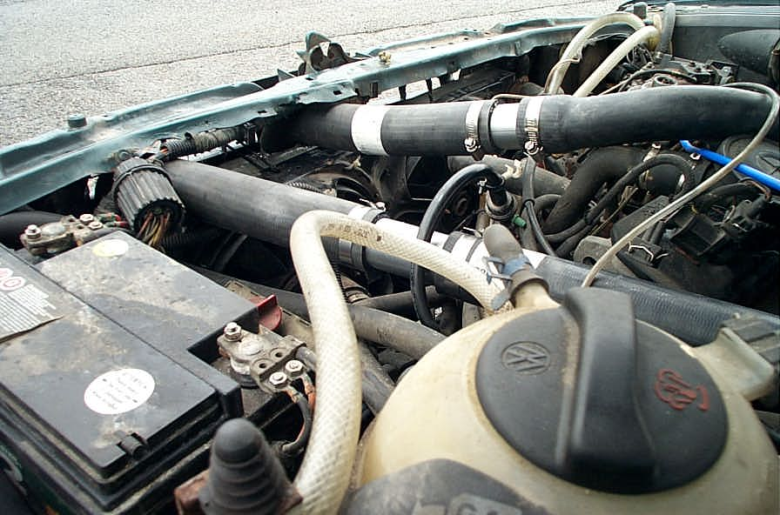
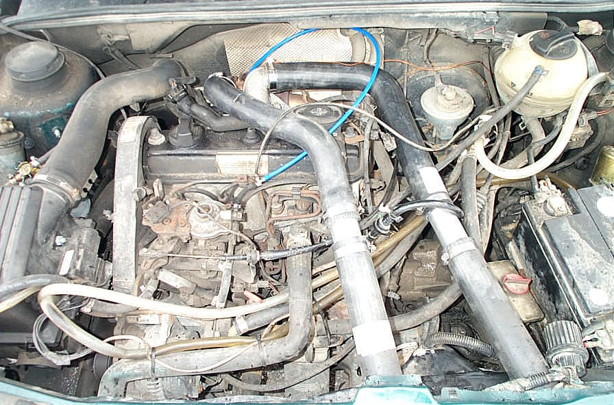
good luck in your projects

