

Land rover 200t di and 300t di
adjustments of Standard the BOSch pumps ve

Caution !!!

This document was made for my personal use, you can make use of it freely but I decline any responsibility when with l.utilisation that you will make some.
Since l.apparition of these engines one intends to speak about more or less secret "preparations", more or less expensive. A heap d.informations circulates, of the thousands of messages were written on the forums of the whole world and j.ai decided to make my synthesis of this information and my experiment.
My principal d.information sources on the Net :
- In French
Landmania forum by making a research with l.icône and the words optimization, Rory.
Rory method to be downloaded (thank you in Frederic Dépt79 for the bond)

- In English
Forum LRE to envisage a few hours of reading for this super post
American site the base of the preceding post
And well d.autres that I let to you seek.

A drawing and some photographs simplifying the explanations :

PHOTOGRAPH 1

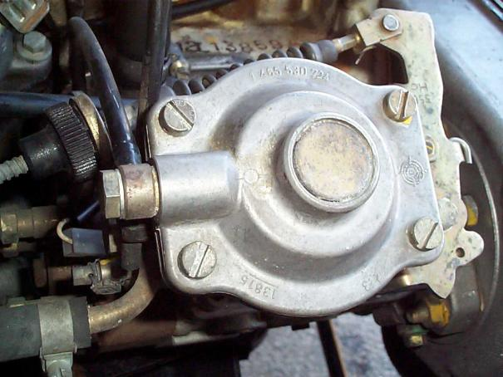
L.objet which interests us
DRAWING 1

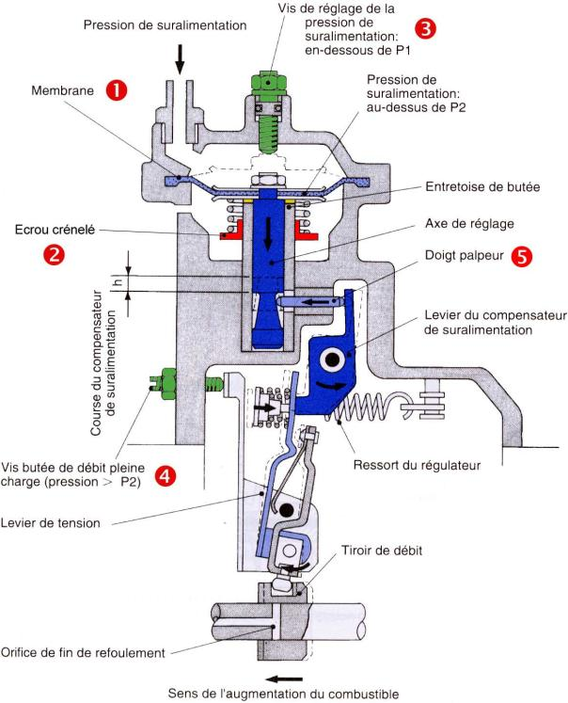

The system is represented in turbo position in pressure (see the dotted lines for the position at rest)
What let us seek ?

On our machines and for l.utilisation that l.on in fact, c.est especially of the couple and the power with low mode which interests us.
For that, it is necessary to manage to have a more significant mass fuel rate of flow as soon as possible.

How to make ?

If drawing 1 is looked at, one s.aperçoit qu.il was ridden on these pumps a system (the LDA) allowing to limit the mass fuel rate of flow when the turbo n.envoie not of pressure, this in order to reduce fume and pollution. There are a whole set of levers and springs which are ordered by a feeler finger  to vary the drawer of flow.
To have a maximum capacity this feeler finger must be readiest possible of l.axe of the stem which supports the membrane.
One sees on photograph 2 that the stem in question, bolted on the membrane, comprises at its base a conical machining which are excentré compared to the stem and c.est this cone which orders the feeler finger. The finger moves only in the longitudinal direction and the stem in the vertical direction thus more I descend the membrane, plus the finger approaches l.axe and if I turn the membrane, my finger approaches or s.éloigne my axis.
It is thus necessary to turn the membrane to have a maximum capacity without monstrous smoke and to reduce the compression of the spring for qu.une small pressure of turbo starts to reduce the cone.

PHOTOGRAPH 2

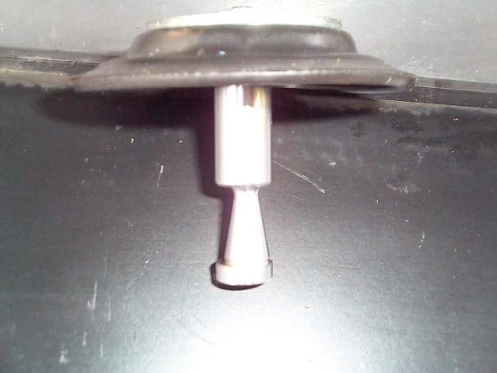
The membrane left the pump. L.excentricity of the cone is noticed
In practice

- To unscrew the 4 screws on the top of the pump (photo 1). To envisage a screwdriver of the good dimension and if possible with recovery for a key, the screws can be very tight.
- To gently withdraw the lid without making it turn if the membrane would remain stuck below. It is absolutely necessary to locate the position d.origine membrane (Photo 3).

PHOTOGRAPH 3
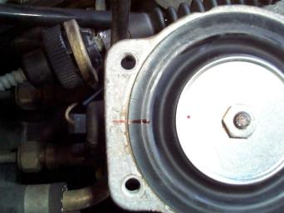
The membrane in position and located

- To gently leave the membrane and its stem. If it does not leave, to turn the membrane while raising it, the cone will release the feeler finger of the base of the stem. One finds below a spring posed on a kind of toothed wheel : l.écrou crenelated  who is used for the adjustment of the tension of the spring (photo 4).
- To put side the spring and to locate the position of l.écrou.

PHOTOGRAPH 4
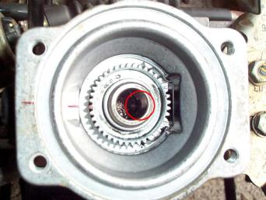

Crenelated L.écrou and in the circle one sees the feeler finger
- Each turn d.écrou (direction of the needles) reduced the base from the spring d.1 Misters One should not too much go down if not the spring will not be any more in tension lorsqu.on will put back the lid and the cone will move all alone.
- To go up l.ensemble by leaving for the moment the membrane on its reference mark d.origine and by checking qu.on has a light pressure well on the spring with the reassembly of the lid.
- To test the vehicle to check qu.il does not smoke too much. L.essai must be made full load i.e. if possible coast and full acceleration for a mode of 2500/3000 rpm. If the conditions cannot be met, to be useful itself of the brakes to put it in load (not too a long time, the brakes heat very extremely under these conditions).
- Return to the garage, it smokes too much : l.écrou was screwed too much, to unscrew it and remake l.essai ; c.est normal : one passes to the adjustment of the membrane.
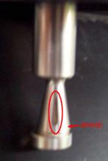
- Lorsqu.on looks at the cone, one sees a vertical mark left by the friction of the feeler finger. By holding the stem with the membrane upwards, it is necessary to locate if this mark is on the right or on the left of the " bump " of the cone (the part of the cone which is closest to the circumference external of the stem). On the photograph opposite the mark is on the left of the bump. If the mark is on the left, it will be necessary to turn the membrane towards the left (direction opposite of the needles) and conversely if it is on the right.
- the maximum capacity is obtained when the feeler finger with is l.opposé of the bump, it is necessary to try to locate it, that will give the maximum value of rotation of the membrane.
- To reassemble the membrane by making it turn d.environ 15° in the direction defines above compared to the reference mark made at the beginning.
- To carry out the tests under the same conditions that for the spring and to increase 15° as long as smoke is " acceptable " without exceeding the value of maximum rotation (if not one return out of AR).

My adjustments

Castle nut : 1 turn (there remains to me 0,5 mm of pressure on the spring, I can still make ¼ tr)
Membrane : 45° (I am with half of the maximum)
Turbo : 0,9 bar (6 turns on the stem of pushed wastegate)

Resulted are surprising : no additional smoke, the engine seems to turn rounder, less noisy, of the astonishing resumptions with very low mode and it is felt that the engine wants " to push ". Where it pained to climb a coast, I pass the higher report/ratio and it continues to accelerate !!

Still more ? DANGER Attention !

For those which would be at the end of the adjustments indicated, there are still easy ways which allow d.aller a little further.
If while turning the membrane one arrives at the point of maximum flow, it is necessary to screw the screw  (drawing 1) what makes it possible to reduce the nose cone the pressure from overfeeding and thus d.augmenter flow on all the beach d.utilisation of the LDA. to obtain this screw it is necessary to remove the metal mask (photo 5) on the top of the lid (2 small screwdrivers to make lever). To loosen the counter-nut (key of 13) then to tighten the screw (torx 25) one can go jusqu.à 2 turns. Not to forget to regulate consequently l.écrou crenelated (one retightened the spring by the top). It will be perhaps useful to reduce or remove the plastic ring under the membrane in order not to arrive into obstinate on this ring when the turbo one is in pressure.
PHOTOGRAPH 5

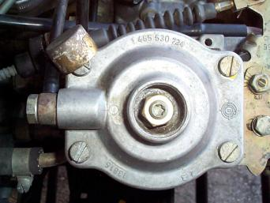
Access to the adjustable tangent

It is also possible d.augmenter the general flow of the pump by modifying the adjustment of the screw of butted of flow of full load ( dessin1).
This screw is to l.arrière of the pump close to the pipes d.injecteurs (one sees it on photograph 1) and it has a double protection :
- It is leaded or with a plastic mask qu.il is necessary to remove
- There is a very resistant metal setting qu.il is necessary to destroy (Dremel recommended)
Adjustment by screwing to 2 turns.
For the turbo one, maximum pressure 1 Bar, one arrives at the limit of the acceptable gas temperatures d.échappement.
For all these adjustments of the reference marks before modification are essential in order to be able to return to l.état initial in the event of problem (or of passage to the vehicle inspection). To carry out progressive tests.

Not to forget

A clean air filter and the most effective possible intercooler will give a better output to the engine.

While hoping to have helped you, good careful adjustments with all landmaniacs.

Make me starts from your remarks and from your resulted here

@ + Phil

